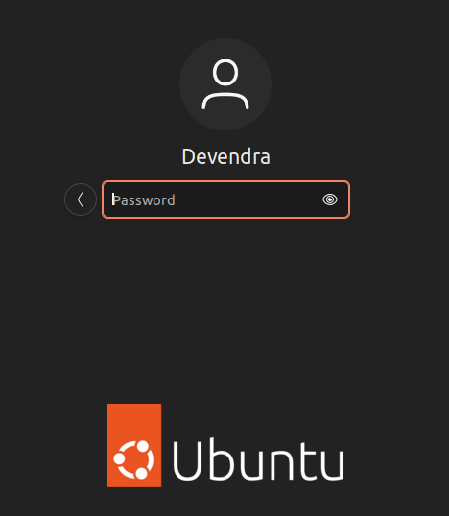1.



2.

3.

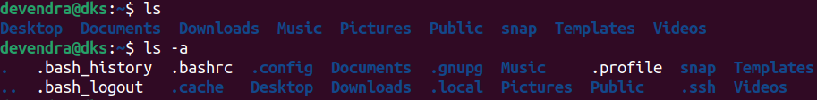4.1

While using ls command it shows all the regular files and directories

When we are using ls -a , it shows all directories including hidden files

4.2 4096 max size

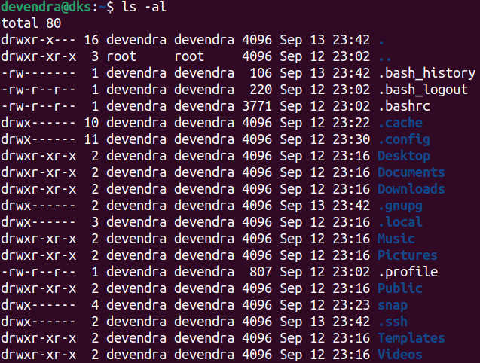

5. Unable to get it

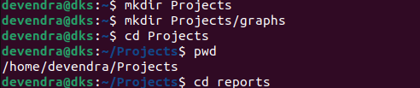6.1



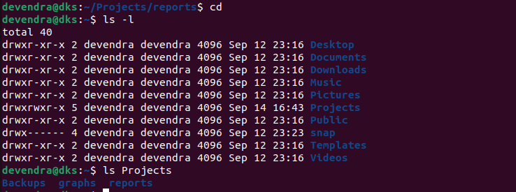

6.2

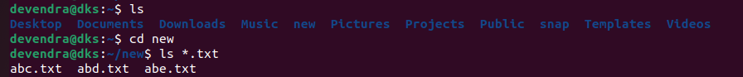

7.

8.

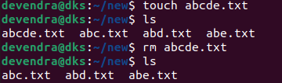

9.

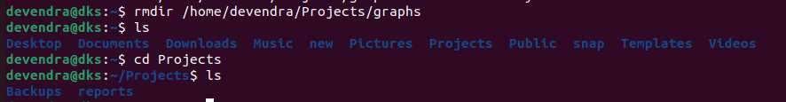

10.



11.

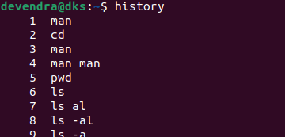

12.



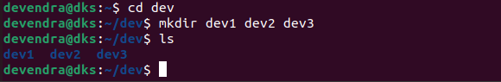13.

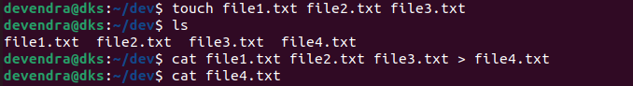14.

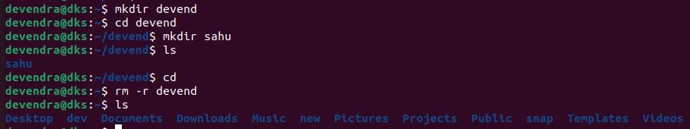15.